**EAS II Installation Instructions**

**Instructions:**

* If already using EAS II, create a backup of your workspace. This can be done by using the Save As option in System Configuration (System Configuration->Workspace File->Save As). See screenshot below

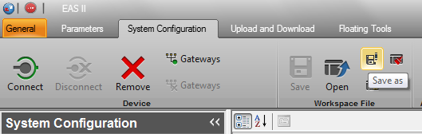

* Uninstall existing version of EAS II
* Install .NET Framework 4.5: <https://www.microsoft.com/en-us/download/details.aspx?id=30653>
* Install EAS II (Elmo Application Studio II Setup 2.2.1.0.exe)
  + *Note: Installation requires Administrator privileges*
* After installing, open EAS II; your original workspace will open. Verify that you can connect to the devices in your workspace
  + *Note: If using the Gold Maestro it’s recommended to update the Gold Maestro firmware to 1.1.6.0 and also create a new EtherCAT configuration in order to use new EtherCAT features in the GMAS.*
* It’s recommended to set the logging level for EAS II to Trace, for maximum logging detail. This can be done as shown in the screenshots below:

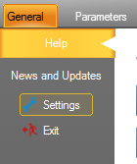

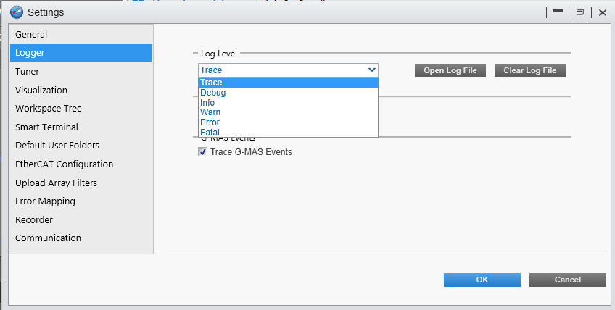

* Install the Recording Data Viewer (Recording Data Viewer Setup 2.1.1.0.exe)
  + This allows Elmo Data Viewer recordings (EDV) to be used in a standalone recorder application and also allows users to open the EDV file by double clicking on the file.